**CONTENT**

|  |  |  |
| --- | --- | --- |
| **S.No.** | **CONTENT** | **PAGE No.** |
| 1. | Abstract | 2 |
| 2. | Project Overview | 3 |
| 3. | System Design | 4 |
| 4. | System Flowchart | 5 |
| 5. | Input Design | 8 |
| 6. | Output Design | 8 |
| 7. | Menu Level Description | 9 |
| 8. | Process Specification | 10 |
| 9. | Screen Layouts | 11 |
| 10. | Conclusion | 13 |
| 11. | Bibliography | 14 |

**ABSTRACT**

# The Hostel Management System is a web-based application designed to streamline and automate the management of hostel operations in educational institutions. It addresses the common challenges associated with manual hostel record-keeping such as room allocation errors, inefficient tracking of student accommodations, and the lack of real-time data visibility. By digitizing the student registration and room assignment process, the system ensures improved efficiency, accuracy, and transparency in hostel administration.

# The system provides a centralized dashboard that visually displays key hostel statistics including the total number of rooms, available rooms, and the number of currently accommodated students. This real-time data helps hostel wardens and administrators make quick and informed decisions regarding room availability and occupancy planning. The process begins with student registration, where the administrator inputs relevant student details through a structured form. Once submitted, the system validates the data and dynamically updates the dashboard to reflect the new allocation—automatically decreasing available rooms and increasing the student count.

# Developed using modern web technologies such as HTML, CSS, and JavaScript, the system features a responsive and intuitive interface accessible across various devices. It includes built-in validation to maintain data integrity and supports basic access controls to restrict functionalities to designated users. The modular design of the application allows for scalability, making it adaptable to accommodate additional features like multi-hostel support, student search, fee management, and room reallocation.

# One of the key advantages of the Hostel Management System is its ability to reduce the administrative burden while providing a more organized and user-friendly solution for hostel record-keeping. By replacing traditional paper registers and spreadsheets, the system enhances operational productivity, ensures accurate reporting, and minimizes the risks of overbooking or underutilization.

# INTRODUCTION

### PROJECT OVERVIEW

## The project entitled Hostel Management System is a responsive, modular, and administrator-friendly web application developed to streamline and digitize the process of hostel accommodation management within educational institutions. This system eliminates the drawbacks of manual record-keeping by introducing a digital platform where student registrations, room allocations, and hostel occupancy tracking can be managed accurately and efficiently. Through a structured registration form, administrators can enter key student details such as name, age, department, email, phone number, and room assignment, ensuring consistent and organized data collection.

## Once the student is registered, the system automatically updates the hostel dashboard in real-time, reflecting metrics such as the total number of rooms, available rooms, and number of registered students. This dashboard serves as a central control panel for hostel managers, providing immediate visibility into the status of occupancy and enabling better decision-making. Built using HTML, CSS, and JavaScript, the application is lightweight, cross-platform compatible, and visually intuitive, ensuring ease of use across various devices.

## The system follows a logical and step-by-step workflow, from data entry and validation to dashboard updates, minimizing administrative burden and preventing manual errors. It supports instant feedback and alerts, improving user interaction and enhancing operational transparency. With a focus on data accuracy and real-time updates, the Hostel Management System helps administrators manage accommodations effectively and maintain a reliable digital audit trail.

## Furthermore, the system is designed to be scalable and adaptable, with the potential to integrate additional features such as hostel fee tracking, room change requests, maintenance logging, visitor management, and biometric authentication.

## 2. SYSTEM DESIGN

### 2.1 INTRODUCTION

System design is the process of defining the architecture, components, modules, interfaces, and data structures that collectively fulfil the specified requirements of a software system. It represents the transition from understanding what a system needs to do (as identified in system analysis) to figuring out how to achieve those requirements in a structured and efficient manner. While system analysis answers the “what is” question, system design addresses the “how to” aspect of building or improving a system.

This phase plays a critical role in shaping the success of the project. It involves not only outlining technical solutions but also ensuring that these solutions align with the operational and strategic goals of the organization. System design takes the recommendations from the feasibility study and converts them into a comprehensive blueprint for development, laying the groundwork for the implementation phase.

Before diving into system design, careful planning is essential. It is important to conduct a thorough analysis of the existing system—understanding its limitations, inefficiencies, and pain points—to identify how the new or upgraded system can bring about measurable improvements. This involves evaluating how the integration of computing technologies can enhance overall performance, reduce manual effort, and streamline workflows.

The significance of system design lies in its impact on quality. Design is where the foundation for high-quality software is built. A well-crafted design not only meets user requirements but also ensures maintainability, scalability, security, and efficiency of the system. It acts as a communication bridge between the end-users and the developers by transforming user-oriented documentation into technical specifications that can be interpreted and implemented by programmers, database administrators, and system architects.

Moreover, system design is both a technical and creative endeavour. It demands a blend of analytical thinking, problem-solving, and innovation to architect a solution that is technically feasible, economically viable, and user-friendly. It also includes considering user interfaces, data flows, control logic, and hardware-software integration, all of which contribute to a system that is robust, adaptable, and efficient in meeting its intended purpose.

In summary, system design is not just a step in the development cycle—it is the foundation of a successful and sustainable software product. A strong design ensures that the final system is reliable, efficient, and tailored to meet user expectations and institutional objectives.

### 2.2 SYSTEM FLOWCHART

The classical system flowchart approach to describing and documenting a system will be presented. These system flowcharts are also used in the structured approach that is, form the general to detailed, of the system development life cycle.

Because they have been used to describe system for many years, they are still common in many businesses.

**Basic Flow chart Symbols:**

Process

Input - Output

 Connector

Off page Connector

Data Flow

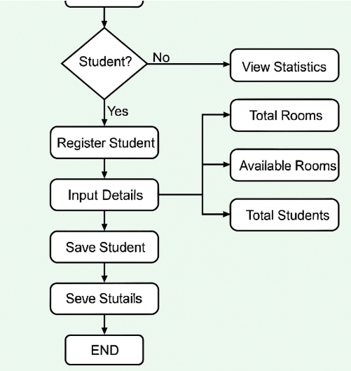

**Fig 2.1 Employee Leave Management System Flow Chart**

**Fig 2.** The operational flow of the Hostel Management System begins with the main dashboard interface, which acts as the central hub for monitoring hostel occupancy and managing student room allocation. This dashboard displays key statistics such as the total number of rooms, the number of available rooms, and the total number of students currently accommodated.

The process starts when the administrator chooses to register a new student by clicking the "Register Student" button. This action redirects to the Student Registration Form, where the administrator inputs essential student details such as:

* Full Name
* Email Address
* Age
* Course or Department
* Phone Number
* Room Number for Allocation

Once the form is filled and the "Register" button is clicked, the system performs input validation to ensure all fields are correctly completed. If the data passes validation, the student is successfully added to the system, and the dashboard statistics are automatically updated. The total student count increases by one, and the available room count is reduced by one, reflecting the new allocation.

If the entered data is incomplete or incorrect, an error message is generated prompting the user to correct the form entries, preventing faulty submissions. This ensures the integrity of the data and helps maintain accurate records.

The flow concludes with a real-time update to the Hostel Statistics Panel, which now reflects the current status of occupancy, helping administrators keep track of room utilization and plan allocations more effectively.

This structured flow ensures simplicity, clarity, and efficiency in hostel room management, reducing manual tracking efforts and enabling better decision-making for student accommodation.

### 2.3 INPUT DESIGN

### 1. Administrator (Hostel Manager):

### Student Registration Form:

### Name: Full name of the student (text input).

### Email: Student’s email address (email input).

### Phone Number: 10-digit contact number (numeric input).

### Department: Academic department of the student (dropdown/text).

### Age: Student’s age (numeric input).

### Room Number: Room to be allocated to the student (dropdown/text).

### Validation:

### All fields are mandatory.

### Phone number must be exactly 10 digits.

### Email must follow valid email format.

### Room number must be selected from available rooms.

### Duplicate room allocation should be prevented.

### 2.4 OUTPUT DESIGN

### 1. Administrator Outputs:

### Registration Confirmation:

### On successful submission, popup: “Student registered successfully.”

### Dashboard updates reflect changes in room occupancy.

### Hostel Statistics Dashboard:

### Real-time metrics showing:

### Total Rooms

### Available Rooms

### Registered Students

### Auto-updated upon each student registration or room assignment.

### Student Record Display:

### Listing of registered students along with:

### Name

### Email

### Department

### Room Number

### Contact Details

### Error Feedback:

### If required fields are missing or invalid:

### Display error messages next to specific fields.

### Prevent form submission until corrected.

## 3. SYSTEM DEVELOPMENT

### 3.1 MENU LEVEL DESCRIPTION

###### The Menu Level Description for the Hostel Management System is organized as follows:

###### 1. Login Menu:

###### Homepage:

###### The main landing page for hostel administrators to enter login credentials.

###### Fields: Username and Password

###### Authentication Result:

###### On successful login, the user is redirected to the main hostel dashboard.

###### On login failure, an error popup is displayed indicating incorrect credentials.

###### 2. Student Registration Menu (Admin View):

###### Registration Form:

###### Allows the administrator to register a new student for hostel accommodation.

###### Fields include:

###### Name

###### Email

###### Phone Number

###### Age

###### Department

###### Room Number (selected from available rooms)

###### Includes a Register button to submit the form.

###### Form validation ensures all fields are correctly filled before submission.

###### 3. Hostel Statistics Menu (Dashboard View):

###### Dashboard Overview:

###### Displays real-time hostel statistics, including:

###### Total Number of Rooms

###### Available Rooms

###### Total Registered Students

###### Automatically updates upon each successful student registration or room assignment.

###### Student List View:

###### Shows a table or card layout with details of registered students.

###### Each entry includes:

###### Student Name

###### Department

###### Contact Details

###### Allocated Room Number

### 3.2 PROCESS SPECIFICATION

Process specification is a systematic approach used to define, analyse, and document the logical steps involved in converting user input into system output. In the Hostel Management System, the process specification outlines how student registrations are handled, validated, and reflected in real-time dashboard updates. This ensures operational accuracy, reduces manual effort, and supports future scalability.

**1. Student Registration Submission:**

**Step1:**  
The administrator accesses the student registration form and enters all required fields:

* Name
* Email
* Phone Number
* Age
* Department
* Room Number (selected from available rooms)

**Step2:**  
The system performs client-side validation to check for:

* Completion of all fields
* Valid email format and 10-digit phone number
* Room availability to avoid duplicate allocations

**Step3:**  
Upon successful validation, the form data is submitted and stored.  
A success popup is shown: “Student registered successfully.”

**2. Hostel Dashboard Update:**

**Step1:**  
Once a student is registered, the system updates the Hostel Statistics Dashboard in real-time.

**Step2:**  
The dashboard reflects the updated values:

* Decrease in Available Rooms
* Increase in Total Students

**Step3:**  
Student details are added to the registered student list view.

**3. Student List Display:**

**Step1:**  
The administrator can view all registered students in a card or table format.

**Step2:**  
Each student record includes:

* Name
* Email
* Phone Number
* Department
* Allocated Room Number

**4. Access Control:**

**Step1:**  
Only authenticated users (admin) can access the dashboard and perform student registration.

**Step2:**  
Unauthorized users are restricted from accessing or manipulating student/room data.

**5. System Maintenance and Scalability:**

**Step1:**  
The system allows future enhancements such as:

* Adding or modifying room data
* Editing or deleting student records

**Step2:**  
Future modules may include:

* Hostel fee management
* Room changes requests
* Visitor log entries
* Integration with biometric or RFID access systems

**4. SYSTEM TESTING**

**4.1 SCRREEN LAYOUTS**

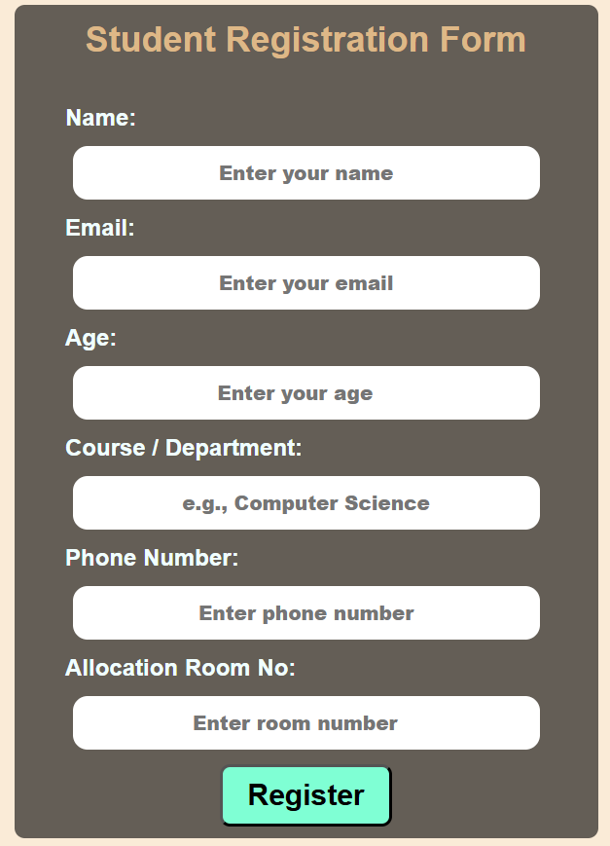

Student Registration Form

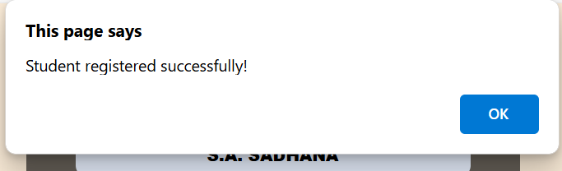

#### Student Registration Successful Popup

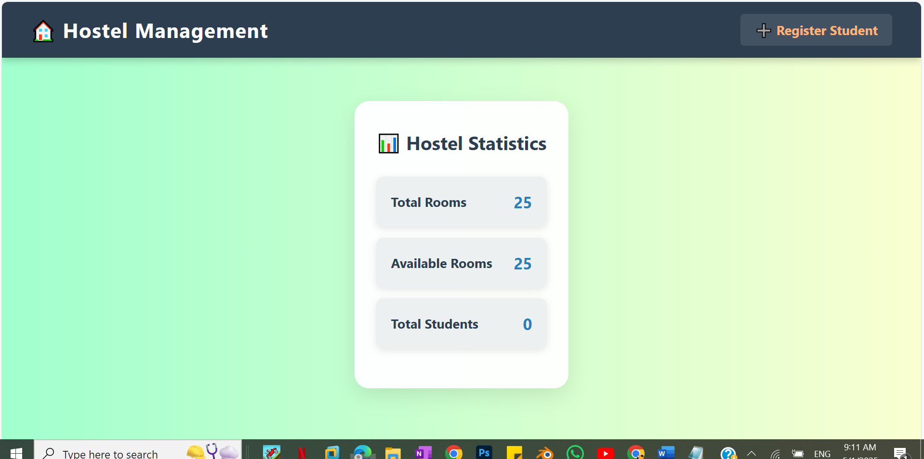

Hostel Dashboard Initial

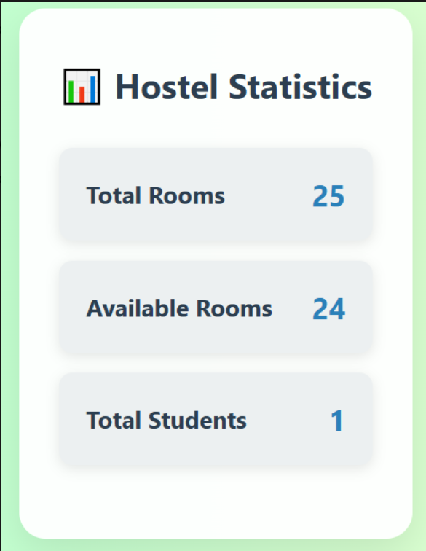

Hostel Dashboard After Registration

## 5. CONCLUSION

## The Hostel Management System is an efficient and scalable web-based solution designed to simplify and automate the process of managing student accommodations within educational institutions. It eliminates the inefficiencies and errors of manual record-keeping by providing a centralized platform for tracking room assignments, student details, and real-time occupancy statistics. This system significantly reduces administrative overhead, enhances data accuracy, and ensures the smooth operation of hostel management.

## By implementing a structured process for student registration and room allocation, the system allows hostel administrators to easily manage room occupancy while maintaining transparency and accountability. The real-time updates to the dashboard ensure that administrators always have access to up-to-date information, enabling quick decision-making and effective planning. Moreover, the validation checks embedded in the system ensure that all data entered is accurate and consistent, reducing the possibility of errors and double bookings.

## The system is lightweight, user-friendly, and responsive, ensuring smooth performance across different devices and platforms. Its modular design enables easy expansion, allowing for the integration of additional features such as fee tracking, maintenance logging, and biometric access control. The system's flexibility ensures that it can scale to meet the needs of both small and large institutions, making it a versatile solution for managing student accommodation.

## With the system's digital audit trail, historical data regarding room assignments, student details, and occupancy levels are always available, which is invaluable for reporting, audits, and policy reviews. As educational institutions continue to embrace digital solutions, the Hostel Management System aligns perfectly with the growing demand for automation, efficient resource allocation, and enhanced communication across departments.

## 6. BIBLIOGRAPHY

1. OpenAI: "GPT-3: Language Models for Text Generation." https://[www.openai.com](http://www.openai.com/)
2. GeeksforGeeks: "Computer Science Portal." [https://www.geeksforgeeks.org](https://www.geeksforgeeks.org/)
3. YouTube: “Various Tutorials and Educational Content." https://[www.youtube.com](http://www.youtube.com/)